Toileting

Self-Help Skills
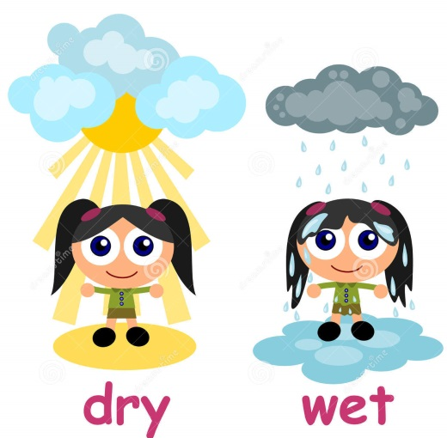
Wet/Dry checks and complete data

Task Analysis

Environmental Preparation and Rewards

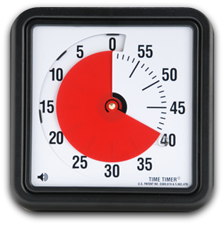
Establish a routine (Visuals Timers)
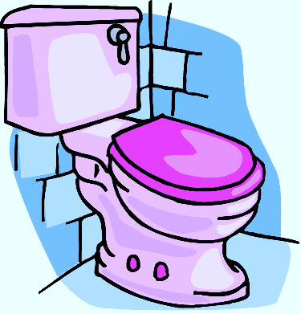

Start toilet trips

Toilet Training
- When getting ready to toilet train, have your child do a “potty party” with a doll that can wet. Make sure the doll has liquid. Set a schedule and have your child take the doll on schedule. Clap and say “hooray” every time the doll “goes potty.” Use horn blowers or whistles to make it a better party.
Give your child a chance to go. If they go, celebrate the same way.
- Use a timer for Toilet Training. You can use a kitchen timer. Set the timer to go off every hour to begin with. When the timer goes off, you will take your child to the bathroom and say: “Time to go to the bathroom”. When the timer goes off again, tell him/her: “Time to go to the bathroom” and follow the bathroom routine from the TEACCH website provided in this packet. Increase the amount of time between setting the timer as your child remains dry for longer periods of time. Provide your child with a lot of liquids (water, juice, etc.) to promote the urge to go to the bathroom. Do not give liquids before bedtime.
Toilet Training: The Student’s Perspective
Even in typically developing children, toilet training is often a difficult skill to master. While the student may have good awareness and control of his body, there are other social factors that determine how easily toileting skills learned. Many children acquire toileting skills to please their parents (being a “a big boy” or “big girl”). This social motivation is a critical factor in determining readiness for toilet training. There are several ways that the characteristics of a child with disabilities may interfere with toilet training:
• Difficulty in understanding reciprocal relationships might inhibit motivation of being a “big boy”.
• Difficulties in understanding language or imitating models may cause the student to misunderstand what is expected of him in the toilet.
• Difficulties in organizing and sequencing information, as well as, attending problems, may make it troublesome to follow all the necessary steps in toileting and staying focused on what the task is all about.
• Difficulty in accepting changes in the routine makes toileting a difficult task. From the student’s point of view, what is the need to change the familiar routine of wearing and changing a diaper? After several years of going in the diaper, this routine is strongly established.
• A student with disabilities may have difficulty integrating sensory information and establishing the relationship between body sensations and everyday functional activities. He may not be able to read the body cues that tell him he needs to use the toilet.
• Sensory issues may play a factor in the environment of toileting. Issues with loud flushing noises, echoes, rushing water and a chair with a big hole in the middle right over water. Issues of change in temperature or tactile feelings of clothes on/off may lead to difficulties with getting undressed. When toilet training a student with a disability, one of the first things we must do is define a realistic goal, realizing that independent toileting may be many steps down the road. Each of the steps may be a goal itself. It is necessary to observe and assess the student’s understanding of the toileting process in order to choose the correct starting point.
Step 1: Assessment
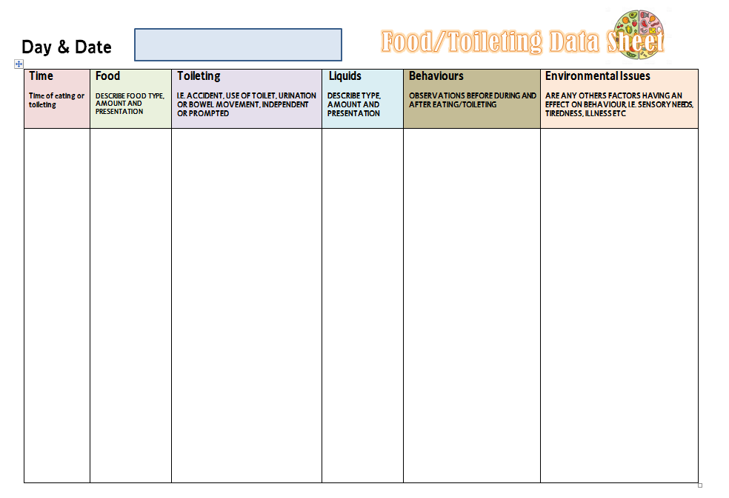
The process should begin with establishing a positive and meaningful routine around toileting and collecting data about the student’s readiness for schedule training or for independent toileting.
A simple chart (see attachment #1) can be used to collect the data needed about the student’s readiness. On a routine basis, the student is taken to the bathroom for a “quick check” every 15 to 30 minutes and data is recorded on each occasion.

Over a period of 2 or 3 weeks, patterns of data begin to emerge.
• Is the student dry for significant periods of time?
• Is there some regularity in his wetting/soiling?
• Does he show any indication that he is aware of being wet or soiled?
• Does he pause while wetting or soiling?

A student for whom the answers to all of these questions is “no” is probably not ready for a goal in independent toileting , although a goal of establishing a positive bathroom routine can still be very appropriate. During the charting phase, we should also be assessing other aspects of the process.
• Is the student beginning to pick up on the routine involved?
• How is the student’s dressing skills?
• Does he show any particular fears or interests related to the bathroom (reaction to toilet flushing, water, toilet paper roll)?
• What is his attention span?
At the end of the assessment period the data should be evident to establish an appropriate goal to work toward.
Step 2: Task Analysis
A task analysis of the steps of toileting can give a picture of all the skills needed. Assessing the student’s current skills on each step will help in choosing a realistic goal and remind you not to try to work on several new skills at once. Task analysis can be global or specific. A sample would be:
1. Enter the bathroom
2. Pull clothes down
a. allows adult to pull
b. Pull from calves
c. Pull from knees
d. Pull from thighs
e. Pull from hips
f. Pull from waist
3. Sit on toilet
4. Get toilet tissue
5. Wipe with tissue
6. Throw tissue in toilet
7. Stand up
8. Pull clothes up
9. Flush toilet
Step 3: Physical Structure
When beginning the toilet training of a student with a disability, we want to help the student learn that this set of behaviours (elimination) is associated with a particular pace (the toilet). Moving all diapering, cleaning, and toileting-related dressing to this setting helps the student realize the purpose of this room.
A second goal for creating clear physical structure to assist in training is to create an environment that is secure and not over-stimulating. The student will be calmer and more responsive with good physical support for his body. Foot support, side rails, opening reducers, or other physical supports may be added. Thinking about the plumbing noises and echoes is necessary. Many students appreciate soft music playing or the addition of sound absorbent materials.
Step 4: Establish a Visually Supported Routine
After establishing an appropriate goal for the student, it is important to teach using visual system visuals for each step toward the goal. It is important to create a visual system to let the student know the sequence of the steps to completing the goal.
At the most basic level, a transition object may be used to let the student know that the toileting routine is beginning. An object that is associated with toileting (a toilet paper roll with a little tissue still left on it) may be given to the student to serve as the transition object that takes the student to the correct location. At a more abstract level, a photograph or line drawing of the toilet or the printed word on a card may be given to the student or placed in the visual schedule to accomplish this goal.
Once the transition to the toilet area has been made, it is important to continue to visually support each step of the toileting routine. By using an object sequence, a picture sequence, or a written list, the student is able to see the information, manipulate the system so that he recognizes its connection to his behavior, and has a clear way to recognize when each step-and the entire process is finished. Attachment #2 is an example of a visual sequence for toileting.

Step 5: Trouble-shooting
Once a visually supported transition and sequencing system has been established, continue to use a problem-solving approach to troubleshooting details. Whenever the student has a problem with any step of the process, think about (1) what his perspective might be and (2) how to simplify and/or clarify through visual structure.
Some examples are:
Resists sitting on toilet
• Allow to sit without removing clothes (practice only)
• Allow to sit with toilet covered (cardboard under the seat, gradually cutting larger hole)
• If strategies are helpful for sitting in other places, use in this setting also (timers, picture cues, etc.)
• Take turns sitting or using a doll as a model
• Sit together
• Add physical support
• Help him to understand how long to sit ( sing a song, length of one song on tape, set timer to one minute)
• As he begins to tolerate sitting, provide with entertainment
Afraid of flushing
• Don’t flush until there is something to flush
• Start flush with student away from toilet, perhaps standing at the door
• Give advance warning of flush, such as “ready, set go!”
• Allow student to flush
Overly interested in flushing
• Physically cover toilet handle to remove from sight
• Give something else to hold and manipulate
• Use visual sequence to show when to flush
Playing in water
• Give a toy with a water feature as a distraction, such as a tornado tube, glitter tube, etc.
• Use a padded lap desk while seated
• Cover the seat until ready to use
• Put a visual cue of where to stand
Playing with toilet paper
• Remove it if it’s a big problem
• Roll out amount ahead of time
• Give visual clue for how much, such as putting a clothespin on where to tear, or making a tape line for where to stop
• Try different materials (wet wipes, etc.)
• Take turns with a doll
Bad aim
• Supply a “target” in the water, such as a cheerio, or commercial made flushable targets
• Add food coloring in water to draw attention
Retaining when diaper is removed
• Cut out bottom of diapers gradually, while allowing student to wear altered diaper to sit on the toilet
• Use doll to provide visual model
• Increase fluids and fiber in diet (7up method: Give student a lot of 7up throughout the day, it is a diuretic and will increase probability of chance elimination in the toilet)
These ideas are not intended to be an inclusive list of steps to take to teach a student to use the toilet. They are, however, illustrative of the problem-solving approach needed and the effort to provide visual cues to increase understanding, cooperation, and motivation.
Important points
• Be Consistent!!!
• School and home should work together on this. Communicate!
• Don’t give up!
• Most students have a routine bowel movement; make sure they are on the toilet at that time!
• Move from diapers to pull-ups right away. When they are dry for longer period of time, move to underwear only. If they have an accident, they won’t like being wet/soiled.
• Continue to move the student to independence. If he is going on his own, gradually move away from the child to standing in the doorway, to being completely out of the room.
Getting Dressed
- Let your child help in getting dressed. If he/she cannot put on the shirt the right way, line up the tag and place the shirt part way over his/her head. Let him/her pull it down. Help your child finish by putting his/her arm in the armhole. Let him/her push /his/her arm all the way through by him/herself.
- Teach your child that the label for pants and shirts goes in the back. Let him/her practice by putting the clothes out for dolls or stuffed animals. Put the label side on the floor. Lay the doll or stuffed animal with its back on the floor. Slide the clothes on. Begin with shirts that button or snap and let them try to button or snap.
- Let your child practice putting buttons through holes. Choose some clothing that has big buttons and big button holes. First take buttons that are loose and slide them through the holes. Then work on the actual buttons on the clothing.
Washing
- If your child is having trouble using soap and washing himself/herself, let him/her practice by washing your arms or face. Let them practice on dolls or windows. Put some soap on the doll or on the window. “Make sure you wipe off all of the soap!” Dry your hands when finished.
- Practice drying off….hands, arms, and legs. Use towels, paper towels, tissues, toilet paper. Feel to see if it is wet or dry. Let your child dry your arms, hands, legs or those of baby dolls.
- Turning water on and off – Help your child learn to turn the knobs on the faucet. Begin with your easiest faucet and work up to the faucet that is most difficult to turn on or off. Have your child fill up a small container for you to use in cooking or cleaning. Let him/her use the water to water a plant or give water to an animal.

