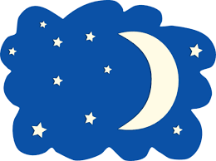
Day & Date
Evening Routine
Time  State the time of the action | Action  What is happening now, i.e. pyjamas, tooth brushing, tea, tv, ipad, fell asleep etc | Foods/Liquids | Behaviours  - How is your child responding to the action  - Who instigated the action, i.e. child decided to watch TV, mum asked child to brush teeth  - How long did this last | Environmental Issues  Are there any other factors, is this particular action new to routine, illness, visitors,

